The goal of this assignment is to get started with a popular prototyping tool, Adobe XD. We will use the tool for the whole semester.

Watch the tutorial here <https://www.youtube.com/watch?v=JttI6YpmPGI>

**Get started with Adobe XD**

1. Choose the prototype size. Depend on what devices you are design for, you can choose different sizes.

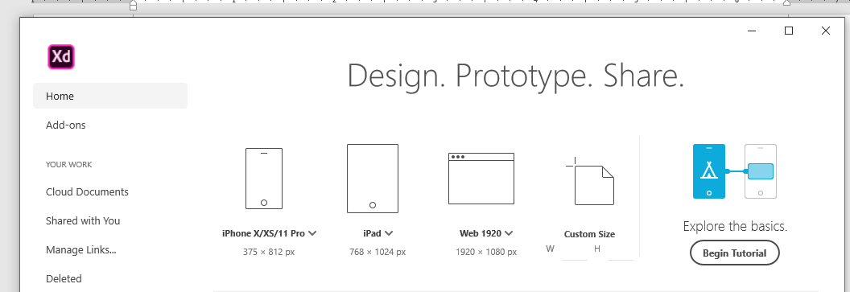

a). How wide your design should be? Check here

<https://www.w3schools.com/browsers/browsers_display.asp>

b). This is the initial screen users will see without scrolling down. However, webpages are usually taller than the Viewport height.

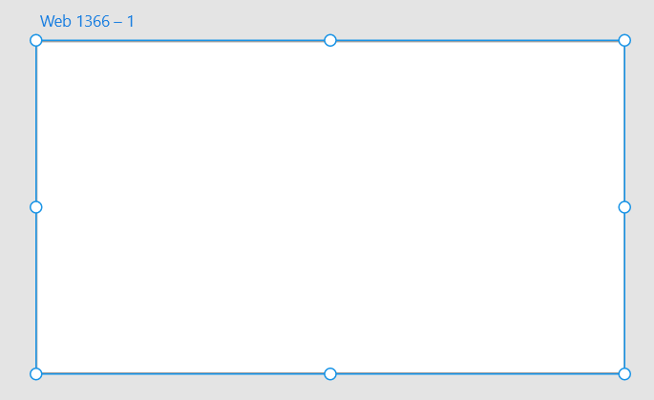

You can drag the bottom to make the Artboard taller for more content.

c). So question1: what is the dotted line for?

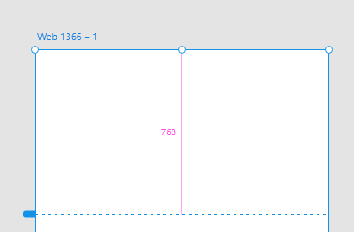

c). Add grids to your wireframe

Check the box under “GRID” on the lower right side of the screen. Grids can help you line things up. Question 2: Why grids usually have 12 columns?

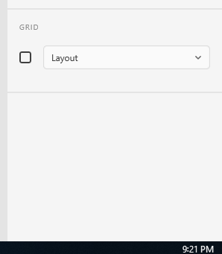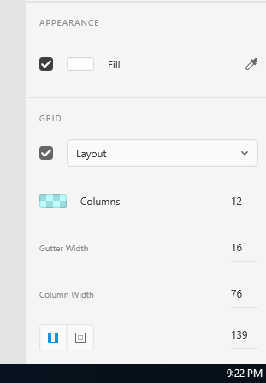

2. Get Wireframe Kits

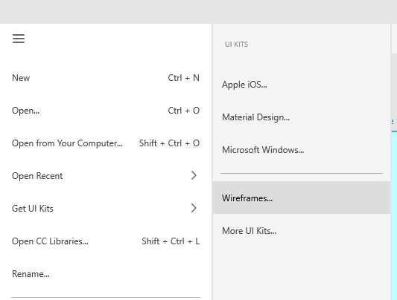

Click the menu in the upper-left corner-> Get UI Kits -> Wireframes

Then download kits from the website

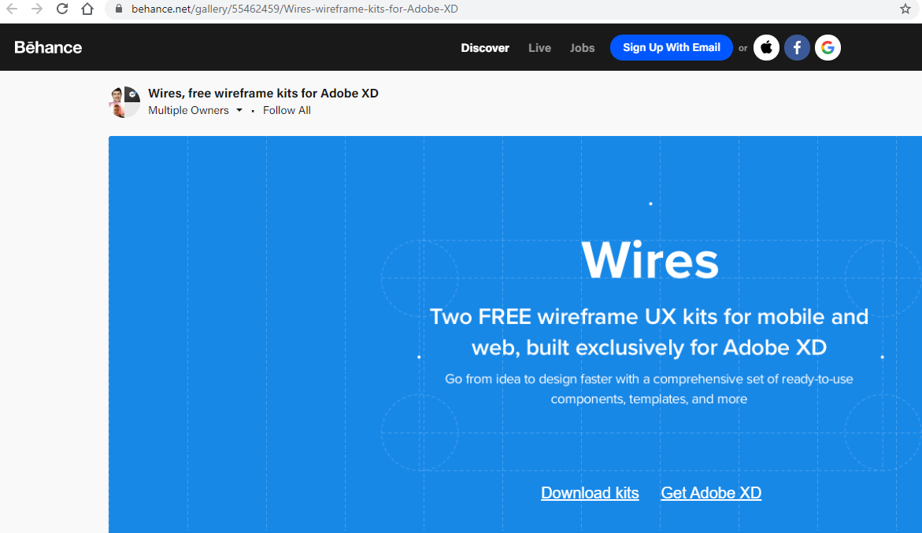

3. Unzip the zip file, and then open the downloaded “Wires – Web” file.

a). Try Ctrl +1, Ctrl+2, Ctrl+3 (select a component first), Ctrl+0 on the template

b). Try shortcuts: Ctrl+ minus, Ctrl + Plus, Hold Space Key and Drag

c). Try to select a component and drag while holding Alt

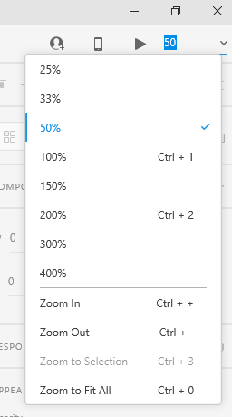

4. Copy a navigation component from the “Wires – Web” file and paste it to your wireframe

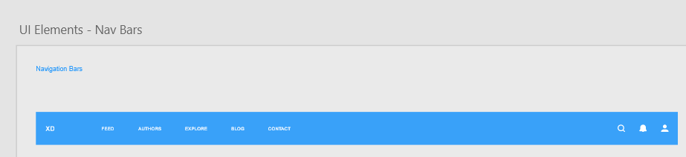

a). Select the XD Symbol in the “ASSETS” in your own wireframe and try “Edit Master in Source Document”

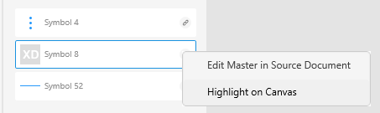

b). In the source document, right click on the selected Symbol, and then click “Edit Master Component”

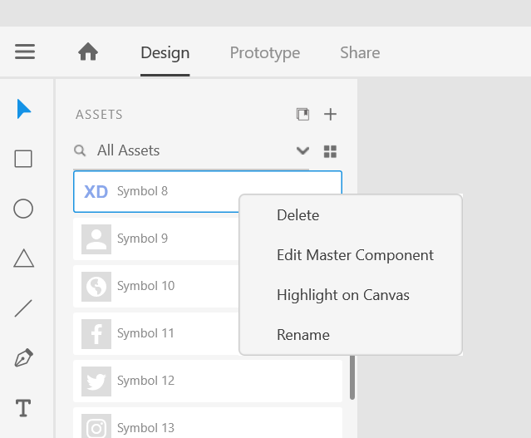

Then go to the right of the screen and scroll down to change the “Fill” to red. Ctrl +s to save the

change

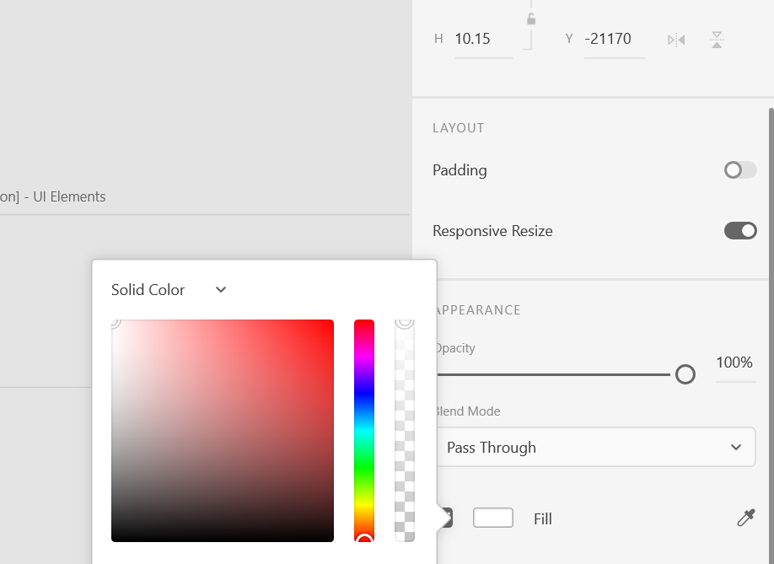

Go back to your own wireframe and click to update the change in your own wireframe

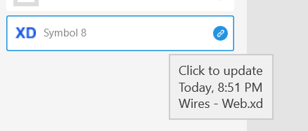

6. Create a webpage wireframe including the following components. No need to be the same.

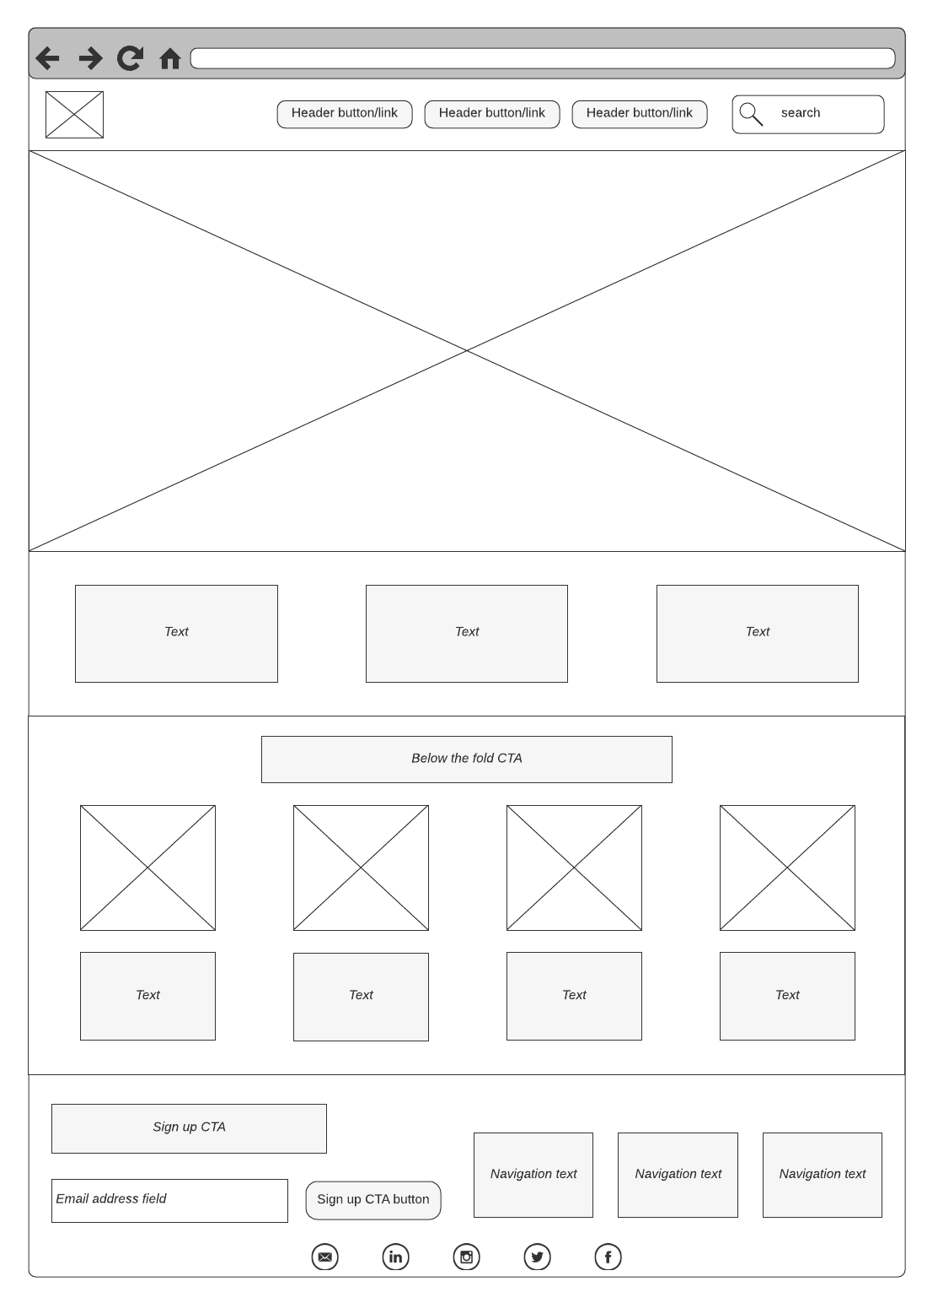

Save your .xd file and submit it to Reggienet by Sept. 7.

Solution: <https://xd.adobe.com/view/0d9d94e0-08f1-48a6-92f6-9e926a95b59d-58ce/>